**INVENTION DISCLOSURE FORM**

**INNOTECH PROJECT ID**

**DEPARTMENT –** Computer Science

**Ques.1. Title of your invention**

FOREWARNING SYSTEM FOR NATURAL CALAMITIES

**Ques.2. Type of Invention**

This invention falls under **Disaster Management and Early Warning Systems**, with a focus on **Machine Learning** integration for predicting, detecting, and communicating natural calamities like rainfall, floods, etc.

**Ques.3. Brief Description of your invention**

The **Forewarning System for Natural Calamities** is an advanced predictive and alert mechanism that leverages machine learning and real-time environmental data to detect, analyze, and forecast natural disasters. The system is designed to enhance disaster preparedness and mitigate risks by providing timely alerts to authorities and the general public.

#### Key Features and Functionality:

* **Integration of Real-Time Data Sources:**
  + Continuously monitors environmental changes to detect early warning signs of potential disasters.
* **Machine Learning and AI-Driven Analytics:**
  + Identifies patterns and anomalies associated with disasters such as **floods**.
  + Enhances prediction accuracy through continuous learning and data refinement.
* **Multi-Channel Alert Dissemination:**
  + Issues early warnings through **mobile networks.**
  + Ensures that alerts reach affected populations, emergency responders, and government agencies promptly.
* **Customizable and Scalable System:**
  + Can be tailored to specific regions, climate conditions, and disaster types.
  + Scalable to function at **local and national levels** benefiting both developed and disaster-prone developing regions.
* **Community Engagement and Preparedness:**
  + Allows users to report incidents and share real-time updates through a user-friendly mobile application.

This system is designed to **enhance disaster preparedness, minimize casualties, and reduce economic losses** by providing accurate, real-time, and accessible early warnings.

**Ques.4. Objective of your invention**

The primary goal of this invention is to enhance **prediction accuracy, reliability, and responsiveness** in disaster forecasting, reducing the impact of natural calamities on human life and property.

#### Key Objectives:

* **Accurate Prediction:** Uses **machine learning** to analyze real-time data for early disaster detection.
* **Timely Alerts:** Provides **instant warnings** via mobile, radio, TV, and social media.
* **Scalability:** Works across **local, national, and global** levels for various disaster types.
* **Risk Reduction:** Supports **early evacuation and emergency response planning**.
* **Public Awareness:** Educates communities and enables participation through a mobile app.

This system ensures **better preparedness, faster response, and reduced disaster impact**.

**Ques.5. How to use the invention**

The system is designed for easy access and usability, enabling individuals, authorities, and disaster response teams to receive **real-time alerts, risk assessments, and safety information**.

#### Step-by-Step Guide to Using the System:

1. **Access the Website**
   * The landing page displays a **welcome message** and a quick overview of the system’s functionality.
   * Users can choose between different options like **View Real-Time Alerts**, or **Explore Disaster Maps**.
2. **Search for a Specific Area**
   * Users can **enter a city name or select a region** on the map.
3. **View Disaster Risk Map**
   * A **detailed map** displays the selected region with key disaster indicators.
   * Information provided includes:
     + **Latitude & Longitude** of the area.
     + **Severity Levels** (e.g., Low, Moderate, High, Critical).
     + **Potential Risks** (e.g., Flash Flood).
     + **Historical Disaster Data** for better risk assessment.
4. **Receive Timely Alerts and Warnings**
   * On the **right-hand corner of the interface**, a dedicated panel shows **real-time alerts and warnings**.
   * Alerts include:
     + **Live notifications** on developing disasters.
     + **Safety instructions and evacuation guidelines**.
     + **Expected impact zones and response measures**.
5. **Get Actionable Information**
   * Users can access **emergency contact numbers, nearest shelters, and government advisories**.

This system ensures that users receive **early warnings, critical disaster information, and actionable safety measures**, helping them stay prepared and respond effectively.

**Ques.6. Problem your invention is solving**

The invention addresses the limitations of current early warning systems, which often suffer from inaccurate predictions, limited reach, and slow response times. It aims to solve the following problems:

* **Inaccurate disaster predictions** due to reliance on traditional methods.
* **Delayed warnings** that hinder timely evacuation and response.
* **Limited communication channels** that fail to reach all affected populations.
* **Lack of integration** between disaster prediction models and emergency response systems.

**Ques.7. Purpose and object of Invention**

The purpose of the invention is to provide an accurate, reliable, and comprehensive disaster warning system that enhances preparedness and reduces the impact of natural disasters. The object is to integrate machine learning for better prediction, utilize multi-channel communication for broad alert dissemination, and provide actionable guidance to the public and emergency services for timely disaster response.

**Ques.8. Discuss potential commercial application of the invention.**

This system can be commercialized in various ways:

* **Government agencies** can adopt it for national or regional disaster management.
* **Private companies** specializing in safety, emergency services, and insurance can use the system to enhance risk assessment and reduce liabilities.
* **Smart city initiatives** can integrate this system into urban safety infrastructure.
* **International organizations** focusing on disaster risk reduction (e.g., UN, Red Cross) can deploy the system in disaster-prone regions globally.

The scalability and adaptability of the system make it highly attractive for commercial partnerships in both urban and rural areas.

**Ques.9.** **Provide any additional material (such as photographs, reports, publications, and references to texts or other information material) which may be helpful to an understanding of the invention identify and indicate the specific relevance of each.**

To aid in the understanding of the **Forewarning System for Natural Calamities**, the following supplementary materials are provided:

#### 1. Screenshots of the Web Application

* **Relevance:** Attached are screenshots of the web-based application that showcase the **user interface and key features**, including:
  + **Search functionality** for disaster-prone areas.
  + **Interactive risk maps** displaying severity levels, latitude, and longitude.
  + **Real-time alerts and warnings** visible on the dashboard.
  + **Multi-channel communication interface** for delivering disaster notifications.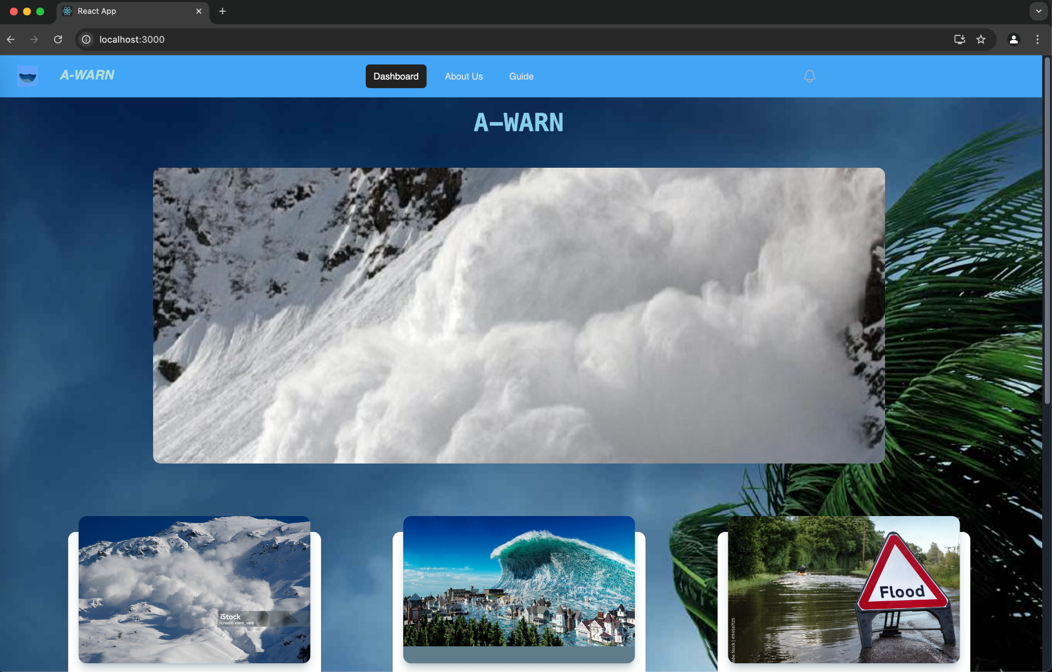

Figure 1: AWARN landing page

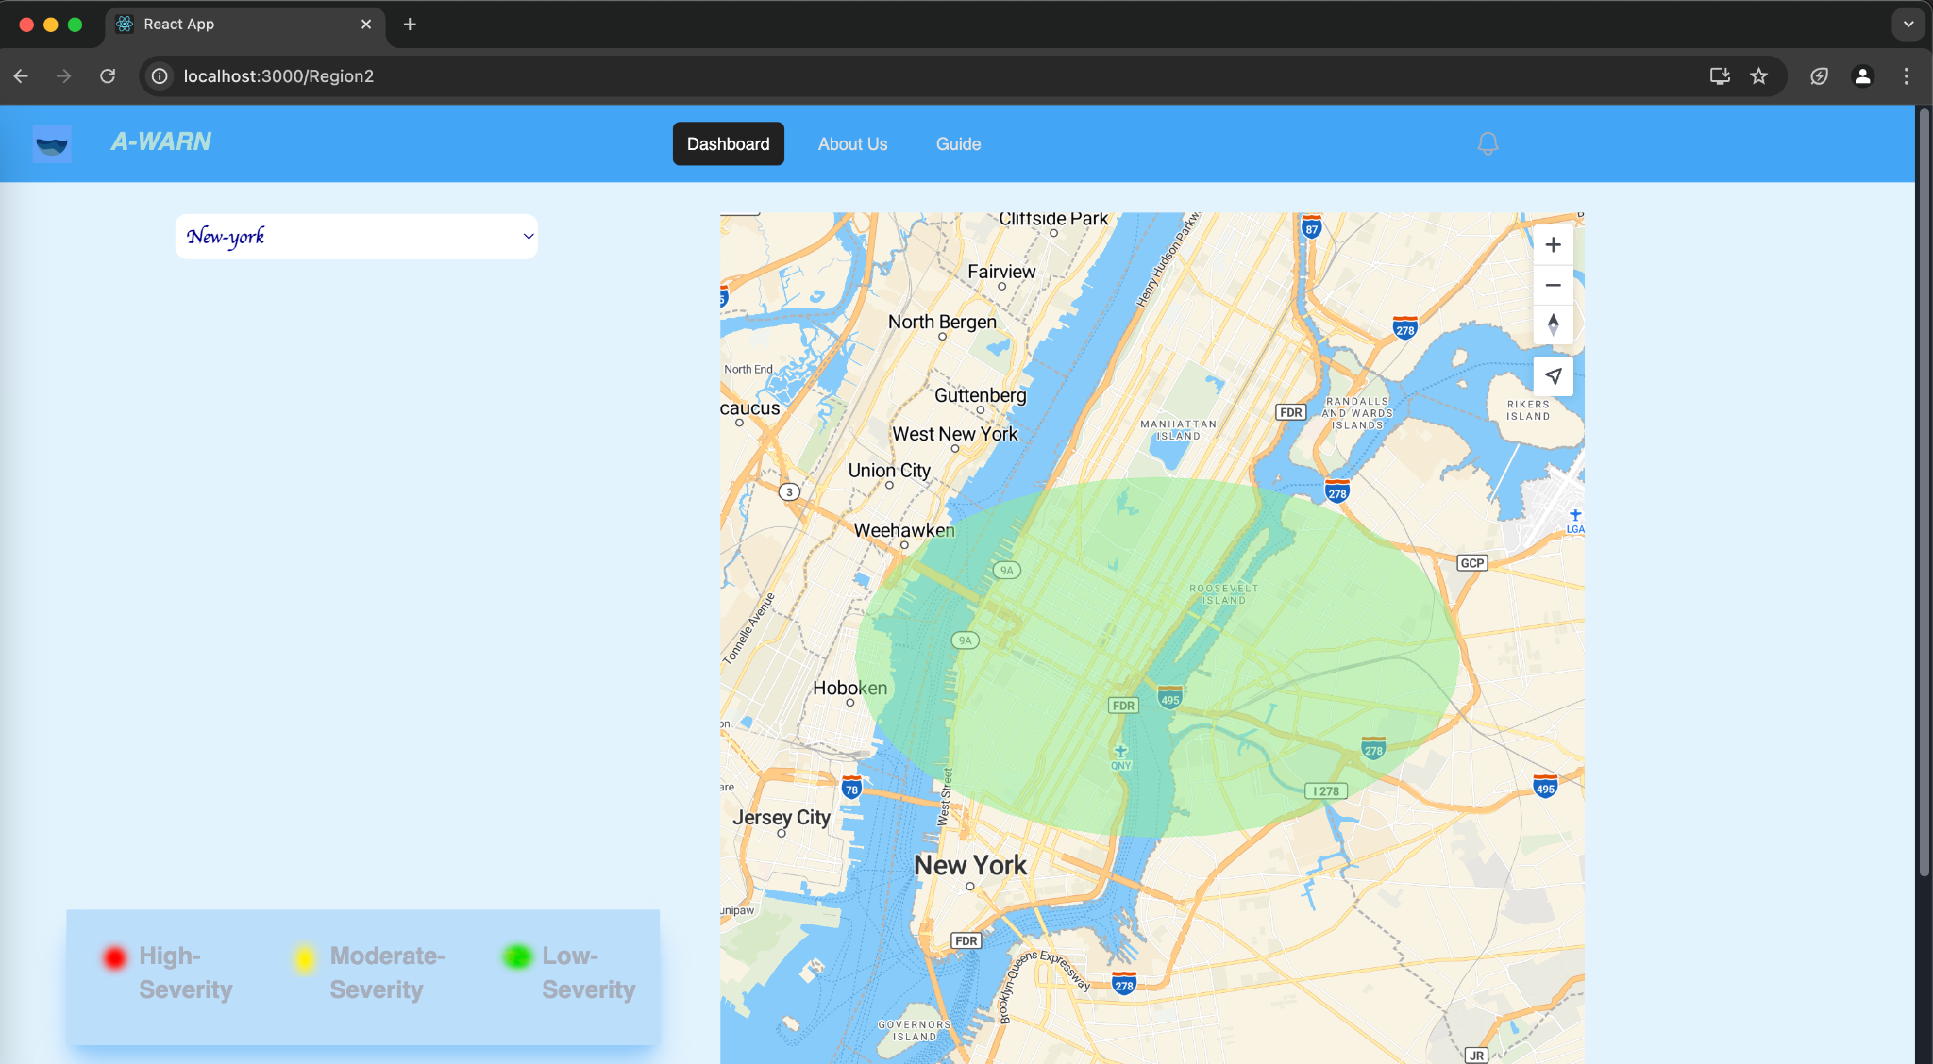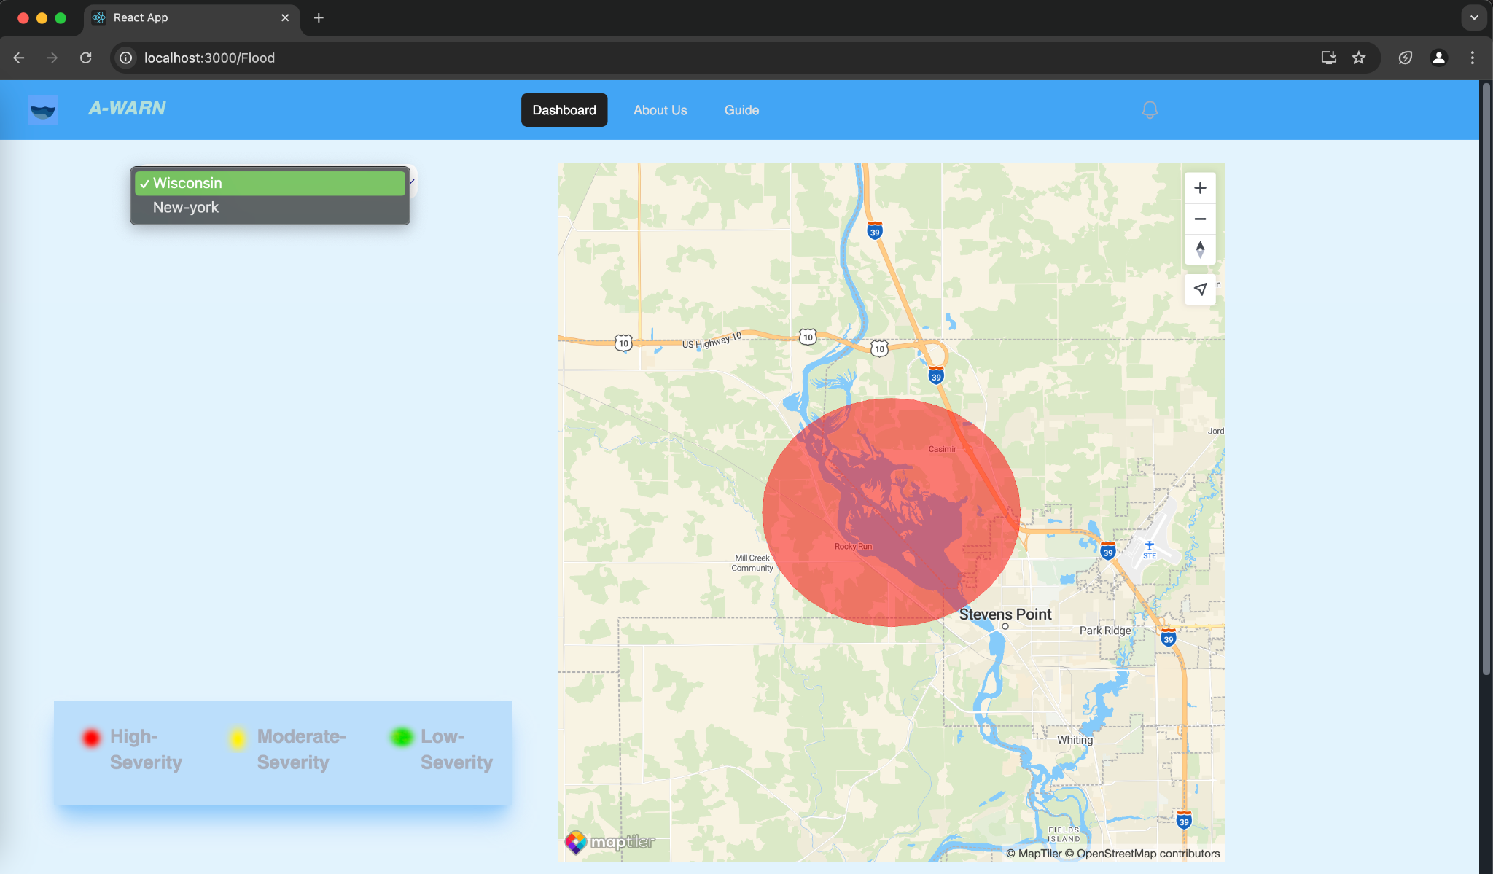

Figure 2: Flood Dashboard

#### 2. Research Publications and References

* **Relevance:** Several research papers have been referenced to support the **methodologies used in disaster prediction and early warning systems**. These cover:
  + **Machine learning models for natural disaster forecasting**.
  + **The references provide a theoretical foundation that justifies the approaches taken in this invention.**

1. M. S. Islam, M. S. Rahman, M. S. Ul Haque, F . A. Tumpa, M. S. Bin Hossain and A. A. Arabi, ”Location Agnostic Adaptive Rain Precipitation Prediction using Deep Learning, ” 2023 IEEE 9th International Women in Engineering (WIE) Conference on Electrical and Computer Engineering (WIECON-ECE), Thiruvananthapuram, India, 2023, pp. 148-153, doi: 10.1109/WIECON- ECE60392.2023.10456479.
2. T. Tang, T. Liu and G. Gui, ”Forecasting Precipitation and Temperature Evolution Patterns Under Climate Change Using a Random Forest Approach With Seasonal Bias Correction,” in IEEE Journal of Selected Topics in Applied Earth Observations and Remote Sensing, vol. 17, pp. 12609-12621, 2024, doi: 10.1109/JSTARS.2024.3425639.

#### 3. Technical Reports on Model Performance

* **Relevance:** Attached reports provide insights into the **machine learning models used for disaster prediction**, including:
  + **Accuracy of different predictive models** for different basins.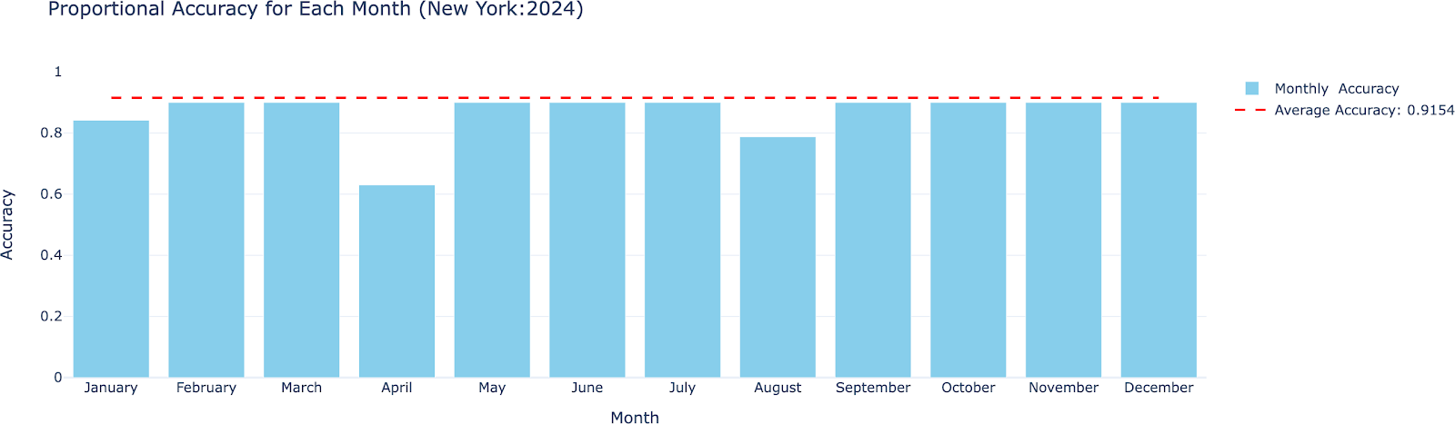

#### 

#### 

#### 

#### 

Figure 4: Monthly Accuracy for New York basins

#### 4. Code and Algorithms

* **Relevance:** The source code used to **train the machine learning model and implement real-time data processing, disaster forecasting, and alert dissemination** is provided. This code forms the foundation of the system, demonstrating its technical approach and functionality.
* **GitHub Repository:** [*https://github.com/aksshatgovind/Awarn*](https://github.com/aksshatgovind/Awarn)

These materials collectively provide a **comprehensive understanding** of the invention, its technical foundation, and its real-world applications in disaster management.

**Ques.10. Abstract**

The present disclosure relates to an advanced forewarning system designed to enhance the prediction, detection, and communication of natural calamities such as rainfalls, floods, etc. The system utilizes machine learning algorithms to predict and assess the likelihood and impact of natural disasters. Alerts are disseminated via mobile networks ensuring timely and broad communication. The system aims to improve disaster response efficiency, reduce property damage, and save lives by enabling timely evacuation and preparation.

**Ques.11. Summary of the invention**

This invention introduces an innovative system that integrates machine learning models with multi-source data collection and communication channels to predict natural disasters with greater accuracy. The system processes real-time data, evaluates risks, and sends alerts to users through mails and other channels. The primary goal is to provide accurate, actionable, and timely disaster warnings, thus improving preparedness and reducing the effects of disasters.

**Ques.12. Detail description of invention with methodology**

The **Forewarning System for Natural Calamities** is powered by machine learning algorithms designed to predict natural disasters. The methodology involves:

1. **Data Collection**: Continuous monitoring of environmental data through historical records, and external APIs (<https://waterdata.usgs.gov/nwis> ).
2. **Data Preprocessing**: Data cleaning, feature engineering, and splitting into training, validation, and testing sets.
3. **Model Training**: Machine learning models like random forests, and threshold-based alerts are trained and validated on the dataset.
4. **Risk Assessment**: The trained models analyze real-time data to predict disaster likelihood and severity.
5. **Alert Generation**: Timely alerts are generated based on set thresholds and disseminated through multiple communication channels.
6. **Feedback Loop**: A feedback mechanism allows continuous refinement of the system based on real-time inputs.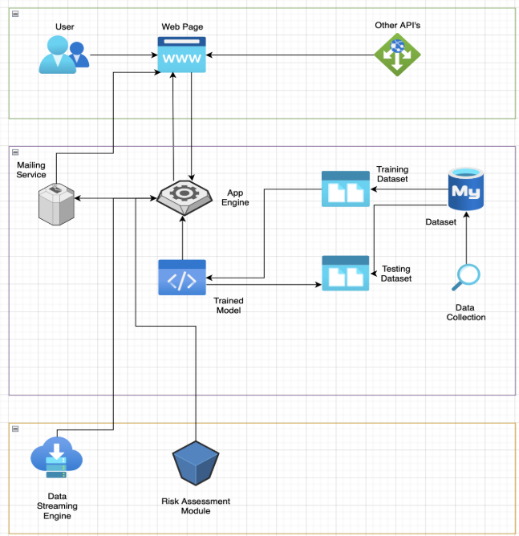

Figure 5: Architecture Diagram of AWARN

**Ques.13. Applicant and inventor details:**

**Applicant Details:**

* **Name**: KIET Group of Institutions
* **Designation**: Institution
* **Institute/Organization**: KIET Group of Institutions
* **Department**: Computer Science
* **Address**: Ghaziabad-Meerut Road, Ghaziabad-201206
* **Email**:
* **Contact Number**:

**Inventor Details:**

1. **Inventor A**:
   * **Name**: Aksshat Govind
   * **Designation**: Bachelor of Technology Student
   * **Institute/Organization**: KIET Group of Institutions
   * **Department**: Computer Science
   * **Role in the Invention**: Machine Learning Lead Developer
   * **Contribution**: Lead the development and implementation of machine learning models to predict and assess disaster risks.

1. **Inventor B**:
   * **Name**: Aishwarya Gupta
   * **Designation**: Bachelor of Technology Student
   * **Institute/Organization**: KIET Group of Institutions
   * **Department**: Computer Science
   * **Role in the Invention**: ML Developer and Data Engineer
   * **Contribution**: Assisted in data collection, cleaning, feature engineering, and the development of machine learning models.

1. **Inventor C**:
   * **Name**: Aviral Katiyar
   * **Designation**: Bachelor of Technology Student
   * **Institute/Organization**: KIET Group of Institutions
   * **Department**: Computer Science
   * **Role in the Invention**: Full Stack Developer
   * **Contribution**: Developed the web interface and communication module for the system, ensuring user interaction and alert dissemination.

1. **Inventor D**:
   * **Name**: Chirag Tyagi
   * **Designation**: Bachelor of Technology Student
   * **Institute/Organization**: KIET Group of Institutions
   * **Department**: Computer Science
   * **Role in the Invention**: Data Collection and Data Processing
   * **Contribution**: Contributed to the gathering of environmental data, assisted in data cleaning and initial processing, ensuring that collected data was ready for use in machine learning model development.

5. **Inventor E:**

* **Name**: Sreesh Gaur
* **Designation**: Assistant Professor
* **Institute/Organization**: KIET Group of Institutions
* **Department**: Computer Science
* **Role in the Invention**: Project Guide
* **Contribution**: Guided and helped in refinement and deployment of machine learning models, providing guidance on system integration and overcoming technical challenges.